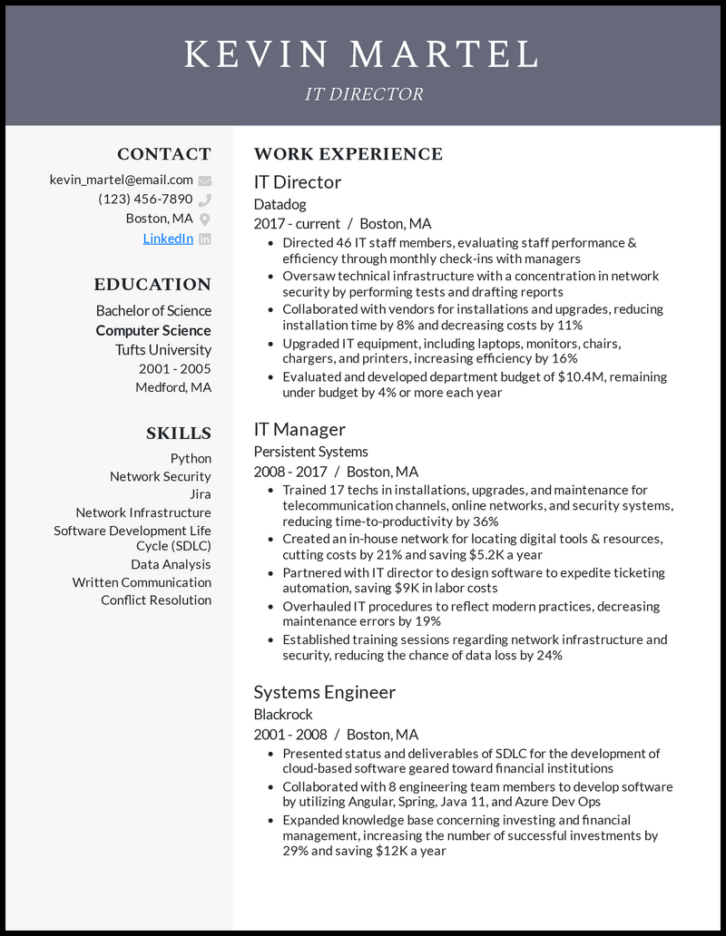
KEVIN MARTEL
IT DIRECTOR
CONTACT
kevin_martel@email.com
(123) 456-7890
Boston, MA
LinkedIn in
EDUCATION
Bachelor of Science Computer Science
Tufts University 2001-2005 Medford, MA
SKILLS
Python
Network Security
Jira
Network Infrastructure
Software Development Life
Cycle (SDLC)
Data Analysis
Written Communication Conflict Resolution
WORK EXPERIENCE
IT Director
Datadog
2017-current Boston, MA
• Directed 46 IT staff members, evaluating staff performance & efficiency through monthly check-ins with managers
• Oversaw technical infrastructure with a concentration in network security by performing tests and drafting reports
• Collaborated with vendors for installations and upgrades, reducing installation time by 8% and decreasing costs by 11%
• Upgraded IT equipment, including laptops, monitors, chairs, chargers, and printers, increasing efficiency by 16%
• Evaluated and developed department budget of $10.4M, remaining under budget by 4% or more each year
IT Manager
Persistent Systems
2008-2017 Boston, MA
• Trained 17 techs in installations, upgrades, and maintenance for telecommunication channels, online networks, and security systems, reducing time-to-productivity by 36%
• Created an in-house network for locating digital tools & resources, cutting costs by 21% and saving $5.2K a year
• Partnered with IT director to design software to expedite ticketing automation, saving $9K in labor costs
• Overhauled IT procedures to reflect modern practices, decreasing maintenance errors by 19%
• Established training sessions regarding network infrastructure and security, reducing the chance of data loss by 24%
Systems Engineer
Blackrock
2001-2008
Boston, MA
• Presented status and deliverables of SDLC for the development of cloud-based software geared toward financial institutions
• Collaborated with 8 engineering team members to develop software by utilizing Angular, Spring, Java 11, and Azure Dev Ops
• Expanded knowledge base concerning investing and financial management, increasing the number of successful investments by 29% and saving $12K a year

